Track 2: Product & Consulting
RavenStack SaaS Analytics — Solution Set
Questions 1, 2, 3, 5, 6, 8
Dataset: ravenstack_accounts, ravenstack_subscriptions, ravenstack_feature_usage,
ravenstack_support_tickets, ravenstack_churn_events

Question 1 — 95% Confidence Interval for Time on App (Premium users)

Approach
In RavenStack, "Premium" users are defined as those on the Pro or Enterprise plan tiers (the two paid tiers above Basic). "Time on App" is operationalised as usage_duration_secs from the feature_usage table — converted to minutes — with each row representing a single feature-usage session for a Premium subscription.
The 95% confidence interval for the population mean is calculated using the t-distribution:
CI = x̄ ± t(α/2, n−1) × (s / √n)

Sample Statistics (computed from data)
Statistic | Value
Sample size (n) | 17,020 sessions
Sample mean (x̄) | 50.89 minutes
Sample standard deviation (s) | 34.29 minutes
Standard error (SE) | 0.2628 minutes
t-critical (α=0.05, two-tailed) | 1.960
Margin of error | ±0.52 minutes

Result
95% Confidence Interval
(50.37, 51.40) minutes per session — we are 95% confident that the true mean time on app for a Premium user session falls within this range.

What this range tells us about engagement
- The interval is extremely narrow (±0.52 minutes around a 50.89-minute mean) because the sample size is very large (n = 17,020). This gives very high precision in our estimate of the population mean.
- Premium users average roughly 50–51 minutes per feature session, indicating deep engagement — well beyond a quick-glance product. This is consistent with a tool that supports core daily workflows rather than ad-hoc browsing.
- The standard deviation (34 minutes) is large relative to the mean — engagement is heterogeneous. Some users spend brief 5-minute sessions while others stay engaged for over 90 minutes. Segmentation by industry, plan_tier, or seat count would likely reveal distinct behavioural cohorts.
- Caveat: this is a session-level CI, not a user-level CI. Because high-frequency users contribute many sessions, the mean is weighted toward them. For an unbiased per-user estimate, the data would need to be aggregated to one row per subscription before computing the CI.

Question 2 — Beta Feature Usage vs Subscription Length: Why Correlation ≠ Causation

Stating the relationship
In RavenStack, accounts whose users engage with beta features (is_beta_feature = TRUE in feature_usage) tend to show longer subscription lengths than accounts that never touch them. A natural — but flawed — conclusion is that exposing more users to beta features will extend their tenure. This conflates association with causation.

Why this is unlikely to be causal
- Beta access is not randomly assigned. Accounts on Pro and Enterprise tiers have privileged access to beta features by product policy, and those same accounts also receive more onboarding, dedicated CSMs, and enterprise contracts. The plan tier — not the beta feature itself — drives both the beta usage and the longer tenure.
- Self-selection bias: only engaged, technically curious users opt into betas. These users would be high-retention regardless of whether the beta program existed. The beta usage is a marker of an already-loyal user, not the cause of their loyalty.
- Reverse causation is plausible: long-tenured accounts have had more time to encounter and adopt beta features. The direction of the arrow may run from tenure → beta usage, not beta usage → tenure.

Two confounders observable in the dataset
Confounder | How it influences both variables | Where it lives in the schema
Plan tier | Higher-tier accounts (Pro, Enterprise) get earlier beta access AND have multi-year contracts with auto-renewal — both ends of the correlation are inflated by tier. | accounts.plan_tier, subscriptions.plan_tier
Account size (seats) | Larger accounts have more users, so the probability that at least one of them tries a beta feature approaches 1. Larger accounts also have higher switching costs and longer tenure. | accounts.seats, subscriptions.seats

How to test for true causation
- Run a controlled A/B experiment: among matched cohorts (same plan tier, same seat range, same industry), randomly grant beta access to one group and withhold it from the other. Compare retention 6 months later.
- Alternatively, apply propensity score matching: pair beta-users with similar non-beta-users on plan tier, seats, signup date, and industry, then compare subscription lengths within matched pairs. If the gap shrinks toward zero after matching, the original correlation was largely driven by the confounders.
Key takeaway for the executive dashboard
Do not market beta-feature usage as a retention lever until a controlled experiment isolates its effect from plan tier and account size. The dashboard should present the correlation alongside a confounder breakdown, not as a standalone causal claim.

Question 3 — Top 5 Features Used by Customers Active >6 Months

Logic
- "Active >6 months" is defined as accounts whose signup_date is more than 180 days before the analysis cutoff.
- The query joins accounts → subscriptions → feature_usage so that each usage event is attributed to the originating account.
- Ranking is by total_usage_count (sum of usage_count) rather than raw event rows, because a single event can record multiple invocations of the feature. unique_accounts is included to confirm breadth, not just depth.

SQL
SQL — ANSI / standard
SELECT
fu.feature_name,
COUNT(*) AS usage_events,
SUM(fu.usage_count) AS total_usage_count,
COUNT(DISTINCT a.account_id) AS unique_accounts
FROM accounts a
JOIN subscriptions s ON a.account_id = s.account_id
JOIN feature_usage fu ON s.subscription_id = fu.subscription_id
WHERE DATEDIFF(DAY, a.signup_date, CURRENT_DATE) > 180
GROUP BY fu.feature_name
ORDER BY total_usage_count DESC
LIMIT 5;
Note: DATEDIFF syntax varies slightly by engine. For SQLite, replace the WHERE clause with julianday(CURRENT_DATE) - julianday(a.signup_date) > 180. For PostgreSQL: CURRENT_DATE - a.signup_date::date > 180. The logic is identical.

Result against the RavenStack dataset
Rank | Feature | Total Usage Count | Usage Events | Unique Accounts
1 | feature_32 | 4,914 | 485 | 260
2 | feature_12 | 4,728 | 475 | 264
3 | feature_2 | 4,701 | 458 | 260
4 | feature_15 | 4,697 | 457 | 247
5 | feature_31 | 4,684 | 466 | 242

Reading the result
- The top 5 features are tightly clustered (4,684–4,914 total uses) and each is touched by 240–264 distinct mature accounts. There is no single "killer feature" — the product has a broad core.
- This breadth is healthy: dependency on a single feature would be a churn risk if that feature ever broke or was removed. RavenStack's mature customers have diversified workflows.

Question 5 — Tableau Dashboard: Cohort Heatmap + Feature Usage Bar Chart

Dashboard concept
The dashboard answers two questions on one canvas: (1) how does retention evolve cohort-by-cohort over time? and (2) which features are these cohorts using? A single global Date filter ties both visualisations together so the executive can scrub through any month and see retention and usage move in lockstep.

Data preparation
- Source tables: accounts (signup cohort), feature_usage (activity events), subscriptions (the join bridge).
- Join in Tableau as a relationship: accounts.account_id = subscriptions.account_id, and subscriptions.subscription_id = feature_usage.subscription_id. Use relationships, not joins, to avoid row-fanout.

Calculated fields
Tableau Calculated Fields
// Cohort = the month an account first signed up
[Cohort Month] = DATETRUNC('month', [signup_date])

// Activity Month = the month a feature was actually used
[Activity Month] = DATETRUNC('month', [usage_date])

// Months Since Signup = position in the retention grid
[Months Since Signup] = DATEDIFF('month', [Cohort Month], [Activity Month])

// Active accounts in (cohort, period) cell
[Active Accounts] = COUNTD(IF [Months Since Signup] >= 0 THEN [account_id] END)

// Retention rate vs cohort size at month 0
[Cohort Size] = { FIXED [Cohort Month] : COUNTD([account_id]) }
[Retention %] = [Active Accounts] / [Cohort Size]

Sheet 1 — Cohort Heatmap
- Rows: [Cohort Month] (descending — newest cohorts on top).
- Columns: [Months Since Signup] (0, 1, 2, … 12).
- Marks: square; Colour = [Retention %] (red→green diverging palette, 0% to 100%).
- Label: [Retention %] formatted as a percentage with no decimals.
- Tooltip: cohort, period, active accounts, cohort size, retention %.

Sheet 2 — Feature Usage Bar Chart
- Rows: [feature_name] sorted descending by SUM([usage_count]).
- Columns: SUM([usage_count]).
- Marks: bar; Colour = AVG([is_beta_feature]) so beta features are visually distinguished from GA features.
- Filter: top 10 by SUM([usage_count]) to keep the chart readable.

Dashboard assembly
- Layout: cohort heatmap on the left (60% width), feature bar chart on the right (40% width). Title bar at top, KPI tiles (total active accounts, avg retention M3, total feature events) above the visuals.
- Global Date filter: drag [usage_date] (DAY granularity) to the dashboard as a Date Range filter. Apply to all worksheets using this data source.
- Cross-filtering: enable "Use as filter" on the cohort heatmap so clicking a cohort cell narrows the bar chart to the features used by that specific cohort in that specific period.
- Add a second filter — [plan_tier] as a multi-select dropdown — so the executive can isolate Premium retention separately from Basic.
Why the global Date filter matters
Without it, the two visuals tell two different time stories. With it, every interaction is on the same temporal page — making the dashboard suitable for monthly business reviews where the date scope changes constantly.

Question 6 — LEFT JOIN: Registered Users with Zero Feature Usage

Schema reality
In RavenStack, the path from an account to feature usage runs through subscriptions: accounts → subscriptions → feature_usage. An account has zero recorded feature activity when no row exists in feature_usage for any of that account's subscriptions. This requires two LEFT JOINs and a NULL filter on the deepest table.

SQL
SQL — Zero-activity accounts
SELECT
a.account_id,
a.account_name,
a.industry,
a.plan_tier,
a.signup_date
FROM accounts a
LEFT JOIN subscriptions s ON a.account_id = s.account_id
LEFT JOIN feature_usage fu ON s.subscription_id = fu.subscription_id
WHERE fu.usage_id IS NULL
ORDER BY a.signup_date DESC;

Why LEFT JOIN (not INNER JOIN)
- An INNER JOIN would silently drop accounts with no matching feature_usage rows — exactly the rows we are trying to find.
- LEFT JOIN preserves every account, fills feature_usage columns with NULL where there is no match, and the WHERE fu.usage_id IS NULL clause then keeps only the unmatched accounts. This is the canonical "anti-join" pattern in SQL.

Result on the RavenStack data
33 accounts have signed up but recorded zero feature usage events.
Out of 500 total accounts, this is 6.6% — a meaningful onboarding-failure cohort. These accounts are the highest-priority targets for activation campaigns because they have not yet experienced product value.

Sample — most recent zero-activity accounts
account_id | industry | plan_tier | signup_date
A-0f6450 | FinTech | Pro | 2024-12-27
A-671f31 | DevTools | Basic | 2024-11-24
A-712426 | HealthTech | Enterprise | 2024-11-10
A-5c9849 | EdTech | Basic | 2024-11-03
A-c37601 | EdTech | Basic | 2024-10-31
A-592832 | Cybersecurity | Basic | 2024-09-25
A-e08cd3 | FinTech | Pro | 2024-09-21

Recommended action
- The Enterprise account (A-712426, signed up 2024-11-10) is especially urgent — Enterprise contracts carry the highest revenue at risk. CSM should contact within 48 hours.
- Build a daily-refreshed dashboard tile from this query so any newly-zero-activity account triggers an automated onboarding outreach within 7 days of signup.

Question 8 — Star Schema for the RavenStack SaaS Dataset

Modelling decision
RavenStack has two distinct business processes that warrant separate fact tables: feature usage events (one row per feature invocation) and support ticket events (one row per ticket). Both share dimension tables (accounts, date) — this technically makes the result a galaxy schema (a.k.a. fact constellation), which is two stars sharing dimensions. The primary star centres on feature_usage.

Fact table — feature_usage
Grain: one row per feature invocation event. This is the most granular and analytically valuable fact table.
Column | Type | Role
usage_id | PK | Primary key (surrogate)
subscription_id | FK | Links to dim_subscriptions
usage_date_key | FK | Links to dim_date
feature_key | FK | Links to dim_feature
usage_count | Measure | Numeric — additive
usage_duration_secs | Measure | Numeric — additive
error_count | Measure | Numeric — additive
is_beta_feature | Degenerate flag | Boolean — could be moved to dim_feature

Dimension tables (minimum 3, four shown)

DIM 1 — accounts
Grain: one row per customer account. Slowly-changing (Type 2 if plan_tier changes need to be tracked historically).
Attributes: account_id (PK), account_name, industry, country, signup_date, referral_source, plan_tier, seats, is_trial, churn_flag.

DIM 2 — subscriptions
Grain: one row per subscription contract. An account can have multiple subscriptions over time (e.g., upgrades, renewals).
Attributes: subscription_id (PK), account_id (FK to dim_accounts), start_date, end_date, plan_tier, seats, mrr_amount, arr_amount, billing_frequency, auto_renew_flag, upgrade_flag, downgrade_flag.

DIM 3 — date
Grain: one row per calendar day. A conformed dimension shared by both fact tables. Built once, used everywhere.
Attributes: date_key (PK), full_date, day, month, quarter, year, day_of_week, week_of_year, is_weekend, fiscal_period.

DIM 4 — feature
Grain: one row per product feature. Lifts feature metadata (category, beta status, release date) out of the fact table.
Attributes: feature_key (PK), feature_name, feature_category, is_beta_feature, release_date, module.

Schema diagram
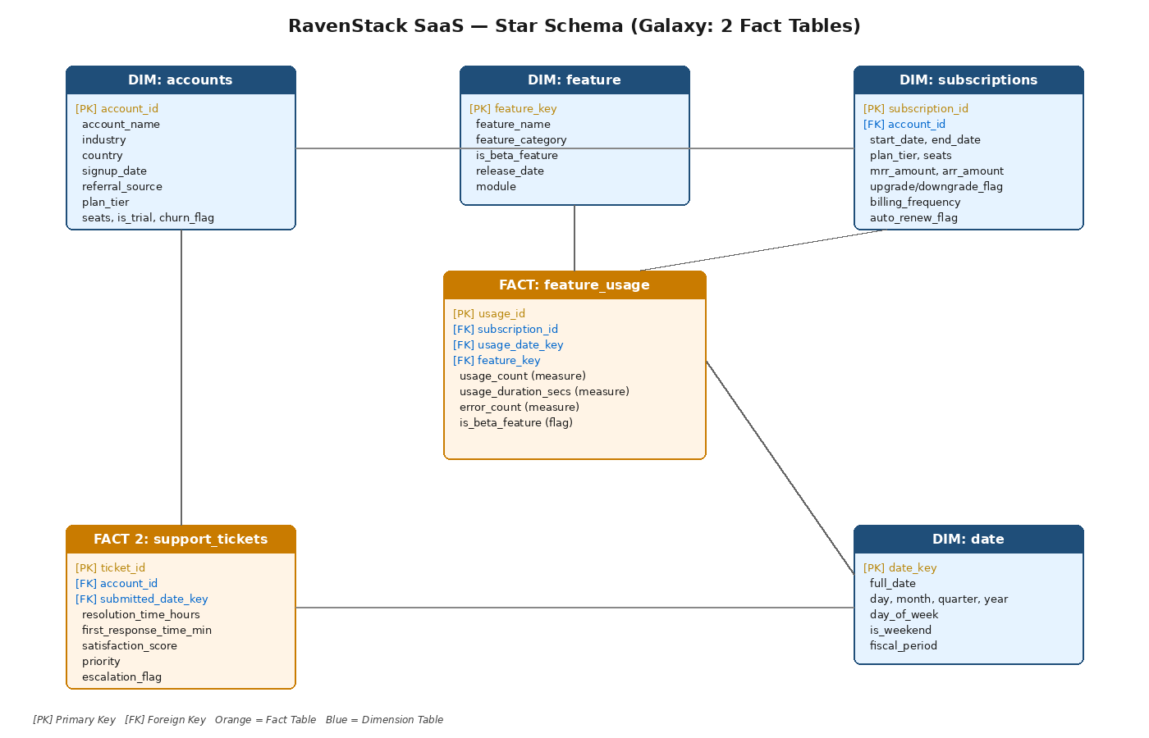
Figure 1 — RavenStack star schema (galaxy variant). feature_usage is the primary fact table; support_tickets is a secondary fact table sharing the accounts and date dimensions.

Why this design works
- Star (denormalized) instead of snowflake: dimensions are not further normalized, which speeds up BI joins and keeps the schema readable for analysts.
- Conformed dimensions: dim_date and dim_accounts are shared between feature_usage and support_tickets, allowing drill-across queries (e.g., "Do accounts with high support volume also have low feature engagement?").
- All measures are additive (usage_count, usage_duration_secs, error_count, mrr_amount), enabling fast aggregation in Power BI / Tableau without complex semi-additive logic.
- Surrogate keys (usage_date_key, feature_key) decouple the fact table from natural keys — making the model robust to source-system changes.

